MAIL BOX ALERT SENSOR::

DESCRIPTION:

Upon receiving new mails or letters in their mailbox, most users do not get notified of this fact. They have to speculatively and periodically check their mailbox contents. In most events, the users are neglectful on checking their mailbox. This at times may lead towards the ignorance of important letters and results in various miseries. Most of the multi story buildings such as apartments, condominiums, office buildings etc limit the users on limited visits to check or collect their letters due to the centralize mailbox location. Users find convenient to be on alert of mails they receive to overwrite the conventional method of checking mailbox. Because of the high confidentiality and official letters are increasing as a corresponding tool globally, the users seek for a better solution which enables them to be on their toes each time a mail is delivered. The state of the art electronics technology is incorporated into these conventional mailboxes as a solution. The programmable logic controller, interface module and the GSM modem can be incorporated by linking the userpsilas mailbox with short messaging system or email facilities and this enables the users to be notified whenever a new mail is delivered. Mails delivered into the users mailbox, the system will automatically generate an alert which is send in the form of a short message system or email that typically details the real time of mail delivery. The system is designed to easy human life by sending short messaging system or email to notify the users about important new mails reaching their mailbox. This is likely to be a fast growing and popular application for short messaging system and email towards the mankind.

DEVICES REQUIRED:

1. Arduino UNO

2. GPRS/GPS Module

3. Pre-paid SIM Card

4.CR 1220 coin battery

5. Photo-resister

6.Letter Box

7. SPST Push Button Switch

8. Grid-style PC Board

9. M-type power plug

10. 9 volt Battery

11. 9 volt Battery Snap

12. 10k ohm resistor

ARCHITECTURAL DIAGRAM:

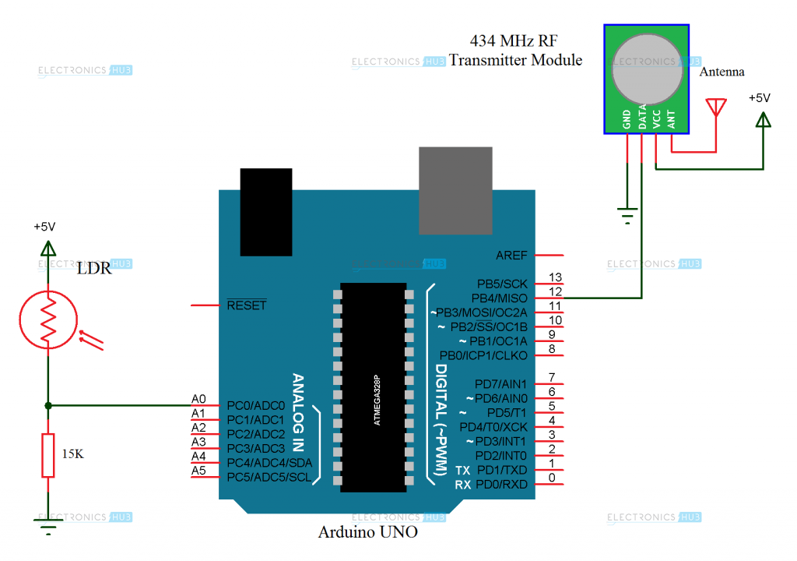

ARDUINO UNO :

**Arduino** is a computer hardware and software company, project, and user community that designs and manufactures [micro controller](https://en.wikipedia.org/wiki/Microcontroller) kits for building digital devices and interactive objects that can sense and control objects in the physical world. Arduino board designs use a variety of microprocessors and controllers. The boards are equipped with sets of digital and analog [input/output](https://en.wikipedia.org/wiki/Input/output) (I/O) pins that may be interfaced to various expansion boards (*shields*) and other circuits. The boards feature serial communications interfaces, including [Universal Serial Bus](https://en.wikipedia.org/wiki/Universal_Serial_Bus) (USB) on some models, which are also used for loading programs from personal computers. The microcontrollers are typically programmed using a dialect of features from the programming languages [C](https://en.wikipedia.org/wiki/C_(programming_language)) and [C++](https://en.wikipedia.org/wiki/C%2B%2B). In addition to using traditional compiler tool chains, the Arduino project provides an [integrated development environment](https://en.wikipedia.org/wiki/Integrated_development_environment) (IDE) based on the [Processing](https://en.wikipedia.org/wiki/Processing_(programming_language)) language project.

GSM MODULE :

GSM is a [cellular network](https://en.wikipedia.org/wiki/Cellular_network), which means that [cell phones](https://en.wikipedia.org/wiki/Cell_phone) connect to it by searching for cells in the immediate vicinity. There are five different cell sizes in a GSM network—[macro](https://en.wikipedia.org/wiki/Macrocell), [micro](https://en.wikipedia.org/wiki/Microcell), [pico](https://en.wikipedia.org/wiki/Picocell), [femto](https://en.wikipedia.org/wiki/Femtocell), and [umbrella cells](https://en.wikipedia.org/w/index.php?title=Umbrella_cells&action=edit&redlink=1). The coverage area of each cell varies according to the implementation environment. Macro cells can be regarded as cells where the [base station](https://en.wikipedia.org/wiki/Base_station) [antenna](https://en.wikipedia.org/wiki/Antenna_(electronics)) is installed on a mast or a building above average rooftop level. Micro cells are cells whose antenna height is under average rooftop level; they are typically used in urban areas. Picocells are small cells whose coverage diameter is a few dozen meters; they are mainly used indoors. Femtocells are cells designed for use in residential or small business environments and connect to the service provider’s network via a broadband internet connection. Umbrella cells are used to cover shadowed regions of smaller cells and fill in gaps in coverage between those cells.

Cell horizontal radius varies depending on antenna height, antenna gain, and propagation conditions from a couple of hundred meters to several tens of kilometers. The longest distance the GSM specification supports in practical use is 35 kilometers (22 mi). There are also several implementations of the concept of an extended cell,[[15]](https://en.wikipedia.org/wiki/GSM" \l "cite_note-15) where the cell radius could be double or even more, depending on the antenna system, the type of terrain, and the [timing advance](https://en.wikipedia.org/wiki/Timing_advance).

Indoor coverage is also supported by GSM and may be achieved by using an indoor picocell base station, or an [indoor repeater](https://en.wikipedia.org/wiki/Cellular_repeater) with distributed indoor antennas fed through power splitters, to deliver the radio signals from an antenna outdoors to the separate indoor distributed antenna system.

GSM Carrier Frequency:

GSM networks operate in a number of different [carrier frequency](https://en.wikipedia.org/wiki/Carrier_frequency) ranges, with most [2G](https://en.wikipedia.org/wiki/2G) GSM networks operating in the 900 MHz or 1800 MHz bands. Where these bands were already allocated, the 850 MHz and 1900 MHz bands were used instead. In rare cases the 400 and 450 MHz frequency bands are assigned in some countries because they were previously used for first-generation systems.

ARDUINO UNO AND GSM MODULE CONNECTION :

 #include <SoftwareSerial.h>

SoftwareSerial mySerial(9, 10);

void setup()

{  mySerial.begin(9600);   // Setting the baud rate of GSM Module

  Serial.begin(9600);    // Setting the baud rate of Serial Monitor (Arduino)

  delay(100);

}

void loop()

{

  if (Serial.available()>0)

   switch(Serial.read())

  {

    case 's':

      SendMessage();

      break;

    case 'r':

      RecieveMessage();

      break;

  }

 if (mySerial.available()>0)

   Serial.write(mySerial.read());

}

 void SendMessage()

{

  mySerial.println("AT+CMGF=1");    //Sets the GSM Module in Text Mode

  delay(1000);  // Delay of 1000 milli seconds or 1 second

  mySerial.println("AT+CMGS=\"+91xxxxxxxxxx\"\r"); // Replace x with mobile number

  delay(1000);

  mySerial.println("I am SMS from GSM Module");// The SMS text you want to send

  delay(100);

   mySerial.println((char)26);// ASCII code of CTRL+Z

  delay(1000);

}

 void RecieveMessage()

{

  mySerial.println("AT+CNMI=2,2,0,0,0"); // AT Command to receive a live SMS

  delay(1000);

 }

PHOTO RESISTOR :

A photo resistor or photocell is a light-controlled variable resistor. The resistance of a photo resistor decreases with increasing incident light intensity. A photo resistor can be applied in light-sensitive detector circuits, and light- and dark-activated switching circuits. It's also called light-dependent resistor (LDR).

ARDUINO UNO AND PHOTO RESISTOR :

int lightPin = 0; //define a pin for Photo resistor

int ledPin=11; //define a pin for LED

void setup()

{

Serial.begin(9600); //Begin serial communcation

pinMode( ledPin, OUTPUT );

}

void loop()

{

Serial.println(analogRead(lightPin)); //Write the value of the photoresistor to the serial monitor.

analogWrite(ledPin, analogRead(lightPin)/4); //send the value to the ledPin. Depending on value of resistor

//you have to divide the value. for example,

//with a 10k resistor divide the value by 2, for 100k resistor divide by 4.

delay(10); //short delay for faster response to light.

}

SPST PUSH BUTTON SWITCH (Single Push Single Throw) :

A push-button (also spelled pushbutton) or simply button is a simple [switch](https://en.wikipedia.org/wiki/Switch) mechanism for controlling some aspect of a machine or a process. Buttons are typically made out of hard material, usually [plastic](https://en.wikipedia.org/wiki/Plastic) or [metal](https://en.wikipedia.org/wiki/Metal). The surface is usually flat or shaped to accommodate the human finger or hand, so as to be easily depressed or pushed. Buttons are most often [biased switches](https://en.wikipedia.org/wiki/Switch" \l "Biased_switches), although many un-biased buttons (due to their physical nature) still require a [spring](https://en.wikipedia.org/wiki/Spring_(device)) to return to their un-pushed state. Different people use different terms for the "pushing" of the button, such as press, depress, mash, hit, and punch.

GRID STYLE PC BOARD :

PC Board is a material for prototyping electronic circuits (also called DOT PCB). It is a thin, rigid sheet with holes pre-drilled at standard intervals across a grid, usually a square grid of 2.54 mm (0.1 in) spacing. These holes are ringed by round or square copper pads, though bare boards are also available. Inexpensive PC board may have pads on only one side of the board, while better quality PC board can have pads on both sides ([plate-through holes](https://en.wikipedia.org/wiki/Via_(electronics))). Since each pad is electrically isolated, the builder makes all connections with either [wire wrap](https://en.wikipedia.org/wiki/Wire_wrap) or miniature [point to point wiring](https://en.wikipedia.org/wiki/Point_to_point_wiring) techniques. Discrete components are soldered to the prototype board such as [resistors](https://en.wikipedia.org/wiki/Resistor), [capacitors](https://en.wikipedia.org/wiki/Capacitor), and [integrated circuits](https://en.wikipedia.org/wiki/Integrated_circuit). The substrate is typically made of paper laminated with [phenolic resin](https://en.wikipedia.org/wiki/Phenolic_resin) or a fiberglass-reinforced epoxy laminate.

WORKING PROCEDURES :

This mail alert system works with curbside, wall-mounted and slot mailboxes that have horizontal hinges that making the mailbox open up or down. On slot and wall-mounted mailboxes, the sensor can be attached to the inside or outside of the mailbox, but on curbside mailboxes, the sensor should be attached to the inside of the mailbox door using the provided double-sided tape. This system will not work with cluster mailboxes or those that operate with vertical hinges.

The device is controlled by the Arduino device and is connected to the Photo resistor. These are inter-connected to by a circular fashion between Arduino UNO, photo resistor and GSM module. Once when there is any change seen in the sensor of the photo resistor, the change of signal is transmitted to the GSM module, which sends an alert to the Contact that is tagged with the module.

Photo resistors also exhibit a certain degree of latency between exposure to light and the subsequent decrease in resistance, usually around 10 milliseconds. GSM networks operate in a number of different carrier frequency ranges (separated into GSM frequency ranges for 2G and UMTS frequency bands for 3G), with most 2G GSM networks operating in the 900 MHz or 1800 MHz bands. Where these bands were already allocated, the 850 MHz and 1900 MHz bands were used instead (for example in Canada and the United States). In rare cases the 400 and 450 MHz frequency bands are assigned in some countries because they were previously used for first-generation systems.

USE CASE SPECIFICATION :

USE CASE 1 : LETTER DETECTION

The purpose of this detection process is the method to detect the Letter received in the Mailbox. The letter which is received in the letter box are detected by the Photo resistor and is controlled by the Arduino about the letter which is received.

USE CASE 2 : ARDUINO CONNECTION

The purpose of this use case specification is to establish the Inter-connection between the Arduino UNO, Photo-resistor and the GSM Module. Then after the connection is established, the letter is detected by the photo resistor and the signal is transmitted to the Module, and the alert message is sent to the resident.

USE CASE 3 : SENDING SMS

The purpose of this use case specification is to send the alert message once a letter is received in the letter box. Once when the letter is fed into the letterbox, the photo resistor fluctuates in the signal. This fluctuation in the photo resistor is sent as a signal to the GSM Module through an Arduino UNO medium and the alert message is sent to the resident.

REFERENCES :

1. David Kushner (2011-10-26). ["The Making of Arduino"](http://spectrum.ieee.org/geek-life/hands-on/the-making-of-arduino). [*IEEE Spectrum*](https://en.wikipedia.org/wiki/IEEE_Spectrum).
2. ["Hardware Index"](http://arduino.cc/en/main/boards). Arduino Project. Retrieved 2013-12-10.
3. “The Arduino source code”. The Arduino source code.
4. Programming Arduino: Getting Started with Sketches; Monk Simon; 162 pages; 2011; ISBN 978-0071784221.